The Story Behind the Criterion:

Water Dependent Recreation in the Sacramento-San Joaquin Delta

Just Transitions in the Delta: Drought, Sea-Level Rise, and Salinity
University of California Multicampus Research Programs and Initiatives

Prepared by
Isaac T. Sanchez &
Jeffrey S. Jenkins

University of California, Merced
September, 2026

What is the criterion: water-dependent recreation in the Sacramento-San Joaquin Delta 3
Definitions 3
Why does this criterion matter? 5
How was this criterion constructed? 7
What are the components of this criterion? 8
Subregional Map 11
What are the Metrics? 12
Measurement Locations 14
Point Locations Used for Recreation Tiered Outflow Runs 16
Metrics: Overall & Seasonal Uses 16
Methods (Overall Use) 18
Methods (Seasonal Use) 20
Adaptation Scenarios Analysis 21
Tiered Outflows Analysis 21
Results 21
Comparative Scenarios Performance Ranking 33
Implications and Discussion 33
References 35

What is the criterion: water-dependent recreation in the Sacramento-San Joaquin Delta

Definitions
Recreation is integral to the Delta economy; in the 2000s, 12 million visitors annually generated an average of $312 million in direct and indirect contributions, supporting approximately 3,000 jobs (Delta Protection Commission, 2012). In the 2010s, overall annual tourism activity days remained at an average of 12 million; however, direct annual spending decreased to an average of $250 million in contributions to the Delta economy. However, a more recent survey indicates that Delta recreation and tourism now support 2,300 jobs – a 26% decrease in recreation-related employment over the previous decade (Delta Protection Commission, 2021). This decrease in economic output may be attributable to prolonged and recurrent drought conditions and the swings between extreme dry and wet years, which create challenges for local communities, seasonal employees, and potential users, especially when ecosystems and species that support this sector are not fully able to recover (Ding et al., 2011; Wlostowski et al., 2022).

While ecosystems in the Delta are adapted to intermittent drought conditions, low inflows to the Delta are associated with increased pollutants and nutrient concentrations, water temperatures, and salinity (Mosley, 2015). Further, hotter and drier conditions in estuarine systems like the Delta have historically led to expansion of submerged aquatic vegetation, which alters habitat and favors non-native predators (Smits et al., 2025). These factors combine with a significant reduction in native and non-native habitats that impact the resource base and ecological processes that underpin water-dependent recreational opportunities (Palmer and Montagna, 2015). For example, striped bass, a valued recreational fishery in the Delta, has shown a statistically significant population decline over time due to drought and coupled food-web responses (Hartman et al., 2024). Prior recreation displacement studies have noted that increasingly erratic droughts and downpour events push people to visit their favorite sites at different times of year than they are accustomed to either later or earlier in the season (Jenkins et al., 2023).

Warmer water temperatures above 19° degrees Celsius may create conditions for harmful algal blooms or HABs to spread, although this is not the entire image as HABs begin to form when the transport of water through an area takes longer than the time it takes biogeochemical processes to happen. And this process is in turn supplementary to the risk is salinity encroachment as fresh water and tidal water mix, via a "X2," a marker of how far saltwater has pushed inland, measured in kilometers from the Golden Gate Bridge to the point where bottom-water salinity reaches 2 parts per thousand (Gross et al., 2019). This is especially the case for wetlands in Suisun Marsh and the Western Delta, where aged levee infrastructure is susceptible to salinity seepage (Hanak et al., 2011).

Geographically, the whole of the Delta region extends nearly 70 miles inland from the Pacific Ocean and comprises a 3,370 km² network of rivers, diked islands, and marshlands, with around 1,330 miles of levees enclosing 57 islands and tracts (Figure 1) (Delta Protection Commission 2012). Leisure boat rides from the western to southern and northern ends take a few days, while flat out traversing the Delta is a full day endeavour. Furthermore, prevailing summer westerly winds make it pleasant to sail eastward into the Delta, while making it difficult to sail west and out of the region (Groc, 2015).

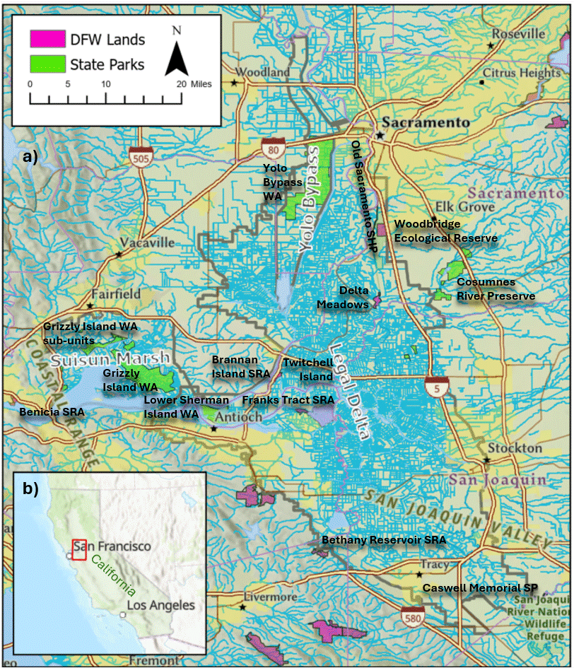
Figure 1. Map of the Delta and Suisun Marsh, including waterways, parks and main roadways.

Why does this criterion matter?
Overall recreational use in the Delta as measured in visitor days includes use from private marinas, launches and moorages for an estimated 4.71 million visitor use days of boating, and 0.66 million non-boating use days each year (California Department of Water Resources, 2022). However, a critical subset of the overall visitors are those who rely on public access largely from state managed units for water-dependent recreation opportunities. This includes those who visit state parks for boating or day use amenities, including 6,040 unique boaters and 477,301 unique day users in 2018 – this during a relatively near-normal climate year and representative of pre-pandemic annual use levels. Publicly accessible waterfowl hunting to largely terrestrial locations takes place at the Yolo Bypass Wildlife Area (approximately 6,696 hunters participating in 2018), and Grizzly Island Wildlife Area and its sub-units (approximately 4,956 hunters in 2018), with a small number of permits issued for Twitchell Island. Additional opportunities for public hunting include locations that require a boat for access, such as with Franks Tract (covered in this study under boating) and at Lower Sherman Island. Birding observations take place at a wide variety of publicly accessible locations, including informal river walks to regional parks, often in conjunction with other activities. Many of these are recorded through phone apps; in 2018, there were 209,249 birder observations reported throughout the Delta in the eBird application.

The Sacramento-San Joaquin Delta and Suisun Marsh are susceptible to drivers of change impacting the region: sea level rise, flooding, salinity, and interannual precipitation changes, which are predicted to reshape recreation outcomes and the Delta landscape as a whole. These drivers of change are anticipated and to a certain extent can be mitigated, through engineered solutions, such as in situ flooding of islands, where needed, and soil acretting crops (Hanak, et al., 2011). Retrospectively the 2012 to 2016 drought was consistent with predictions of climate change for California, as this time period differed from previous droughts as it brought in record breaking high temperatures and low snowpacks (Durand, et al., 2020). This period was reckoned to be the most extreme multi-year drought in California within the last 800 years (Griffin and Anchukaitis, 2014; Williams et al., 2020; Williams et al., 2022), while the fiercely dry period of 2020-2022 had lower precipitation than the driest three years (2013-2015) of the previous record breaking drought (California Department of Water Resources, 2024). On January 1st, 2023, the Cosumnes levee breached following the wettest single storm system since records began 170 years from that date (NASA, 2023). For the majority of the recreation calendar, however, amongst recreationists, the Delta region has been called an “oasis in a mostly arid state”, visitors enjoy the region through the variety of activities, towns, history and scenery (Groc, 2015). Nature parks that depend on winter snow and rain to fill reservoirs, amid changing climate show worse water-based recreation opportunities during drought years through altered visitation seasons, closed waterways, and stressed recreation important species habitats from birds to fish (Chang & Bonnette, 2016).

Previous hydroclimate studies have measured the potential resource effects from increased and decreased runoff and have proposed adaptive strategies related to future water levels at upstream reservoirs (Ray, et al., 2020). While efforts attempting to link climatic variability with recreational use in dynamic delta systems have been limited. We propose a framework to comparatively measure the effects of adaptive scenarios on recreational use for activities that are directly and indirectly dependent on water resources. In quantifying the timing and volume of use for different activities at the year and seasonal levels, we make a novel contribution that is informative for management in understanding implications of potential salinity (conductivity), and water temperature thresholds for seasonally dependent water resources, and how those uses will be increasingly impacted by anthropogenically induced climate change.

How was this criterion constructed?
We selected five water-dependent activities: angling, birding, boating, day use at state parks, and waterfowl hunting, in order to measure those activities against our Tiered Outflows and Adaptation Scenarios. This selection is based on decadal survey and literature records showing these as the Delta's primary recreational passtimes: bird watching, habitat and species conservation interest, fishing tournaments, and publicly accessible day-use activities. As a water convergence zone, the Delta draws visitors from well beyond its own counties; with a primary market extending beyond the Delta to nearby counties in the capital-bay area corridor, and a secondary market reaching as far as Merced, Tuolumne, Monterey, Colusa, and Mendocino (Delta Protection Commission, 2021).

Water-dependent recreation in the Delta depends heavily on snowmelt and winter precipitation; we measure both yearly overall outcomes and seasonal outcomes, to track how activities respond to runoff year type at the year and seasonal peak levels. Furthermore, water-dependent recreation takes two forms: direct activities that depend on water levels themselves (boating, angling, birding), and indirect activities tied to water-dependent species and habitat, such as waterfowl hunting and day use (picnicking, camping, historical and cultural activities). Recreation important ecologic species: fish, birds, and waterfowl respond first to seasonal water conditions, and the recreationists who hunt, observe, or fish for them respond in turn (State Water Resources Control Board, 2025; Jenkins et al., 2026). Our activities: angling, boating, and day use peak in summer (April to September); birding and waterfowl hunting peak in winter (October to March), when migratory species overwinter and hunting permits are issued (Figure 2).
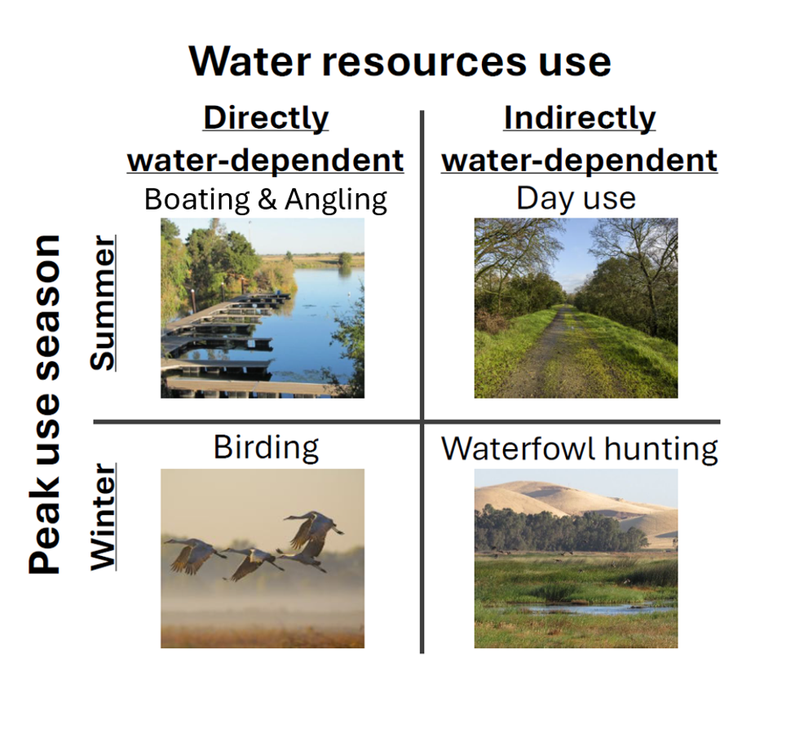
Figure 2. Seasons of the year when direct and indirect water-based recreation activities happen.

What are the components of this criterion?
Angling and boating together are major drivers of visitors to the Delta's five county recreation economy, supported by restaurants, harbors, fueling stations, and boat storage (Goldman et al., 1998; Delta Protection Commission, 2012 & 2021). The largest changes for both activities are the loss of the aforementioned trip supporting amenities (Delta Protection Commission, 2015) as well as, shifting streamflow, water age, and harmful algal blooms that can make access unsafe or undesirable (California Water Quality Monitoring Council, 2026). Drought years (2007, 2016, 2022) have repeatedly restricted access, including for overburdened Delta communities who depend partly on Delta-based resources; in 2016, the Division of Boating and Waterways used pesticides to control HABs closing certain Delta waterways near Delta Meadows and Cosumnes (Hanak et al., 2011; Durand et al., 2020; Rudnick et al., 2025). Statewide water quality, including HAB advisories, range in levels from “None” to “Danger,” and are publicly available and tracked through the state's HAB Reports Map (California Water Boards, 2026).

Angling records come from the Central Valley Angler Survey Database (California Department of Fish and Wildlife, 2023), and are cropped to Delta-tagged survey locations. Surveyed species include American Shad, Chinook Salmon, Sacramento Splittail, Steelhead, Striped Bass, and White Sturgeon, with Chinook Salmon and Striped Bass as the most recurrent species in the datasets. Surveys cover takes from July to December each year from 2018 to 2022.

Boat ramp access was measured via cellular and vehicular counts at roads adjoining 16 publicly accessible motorized boat launches (Buckley Cove Way, Discovery Bay, Morelli Park, Sugar Barge, Bethel Harbor Road, Rivers End, Brannan Island, Tracy Oasis, Antioch City, Big Break Marina, Rio Vista at Montezuma Street, Russos Marina, Hogback Island, Pittsburg Public, Sherman Island, and Sandy Beach) (Streetlight Data, Inc., 2025), data windows cover most of the time-windows associated with our Adaptation Scenarios and Tiered Outflows at daily, weekly, and monthly resolutions.

Birding observations are geo-tagged and time-referenced, downloaded from eBird (Fink et al., 2025) and cropped to recognized California Protected Areas with known public access to birding opportunities within the Delta (GreenInfo Network, 2025; Visit the California Delta, n.d.). This overall analysis yielded 2,077 unique observation locations, with our selections for analysis being (Antioch Dunes, Big Break, Clifton Court, Cosumnes, Grizzly Island, LIberty Island, Rhode Island, Staten Island, Stone Lakes, Van Buskirk park, Yolo Bypass, and Lower Sherman Island).

Day use data is aggregated by monthly visitor counts for Brannan Island State Recreation Area and Delta Meadows; and was obtained from California State Parks for the years 2018 to 2020 (California State Parks, 2023). Available amenities vary by site: Brannan Island offers picnicking, fishing access, swimming, windsurfing, and interpretive exhibits; Delta Meadows offers historical and cultural sites, fishing access, trails, and boating access. Because our day use data granularity cannot isolate individual activities within this category, the two Delta locations are treated as a distinct dataset from boating, birding, and waterfowl hunting. Franks Tract, though data was available, was excluded from this analysis as it is only accessible by water and was omitted to avoid double-counting with boaters.

Waterfowl hunting takes place around Franks Tract, Twitchell Island, and Suisun Bay, supported by private duck clubs and wildlife refuges, with publicly accessible opportunities tallied November through mid-February (California Department of Fish and Wildlife, 2020; Central Valley Joint Venture, 2020). Harvest records from our data cover multiple waterfowl species including Northern Shoveler, Mallard, Aleutian Cackling Goose, and a dozen other duck and goose species. These records were collected at eight publicly accessible wetland units (Yolo, Grizzly Island, Goodyear Slough, Island Slough, Joice Island, West Family Jr., Twitchell, and Gold Hills) from 2018 to 2022 (California Department of Fish and Wildlife, 2023).

Delta recreation economy has grown over time, though it dipped along with national trends during the Financial Crisis and COVID-19. The economic contraction between tourism and recreation, assessed by the Delta Protection Commission, show that the Delta region lost 83 hotels, motels, and bed-and-breakfasts, along with 15 marinas, 16 camping/RV facilities, 17 restaurants, 10 fuel docks, and 13 boat repair shops (Delta Protection Commission, 2021). Even so, Individual sites and events still generate real monetary income to the region, fishing tournaments at Franks Tract bring in roughly half a million dollars a year (Milligan et al., 2020), and a single year of the Rio Vista Bass Derby & Festival generated $301,592 (Mickel et al., 2019). Delta wetlands themselves are estimated to be worth about $1,325 per acre per year in total economic value (CVJV, 2020). Visitor spending varies by activity: boating, fishing, and camping each run about $38.56 per person per day, while hunting runs about $82.44 in expenses inside and outside the Delta combined (Delta Protection Commission, 2021) in 2020 dollars. Birding carries its own value beyond simple spending; a birding trip to see sandhill cranes is worth about $28 to visitors, with each additional 1,000 cranes and bird species adding another $1 to $10 Dollars in value (Melstrom et al., 2024).
Fees also make a large impact, as not all hunting tickets sell out, partially due to not enough hunting locations, but also hunters mention having to pay for their equipment storage, permit fees, and maintenance to the tune of approximately $1,350 (Economic & Planning Systems, Inc, 2020). Recreation under these scenarios should be viewed as the public facing indicator of habitat health, willingness to travel and affordability, as well as habitat access. Gathering the salinity and temperature thresholds for each recreational activity analyzed help reflect how recreation responds to the same thresholds that govern fish, birds, and wetland health and human decision-making; they are placed into perspective as a relevant proxy for ecosystem stress for policymakers and the public to better track season to season the health of their catch and the species they see out there.

Subregional Map
Delta Regions
Activities are aggregated for our three-year Adaptation Scenarios and Tiered Outflow scenarios for the whole Delta, but are also aggregated by four regions we developed specifically for recreation. These four regions are: Suisun Marsh at the westernmost part, followed by the Central Delta which includes recreation important areas like Franks Tract, Sherman Island, and Brannan Island; connected to the North Delta via the Rio Vista Bridge and Highway 12, and to the South Delta, which is split from the Central and North regions by Highway 12 and meanders southward toward Bethany Reservoir to include Discovery Bay in the southern portion (Figure 3).

We selected to split the Delta into regions as we did to closely follow previous regionalizing studies, generating a recreation version of known or modelled regional ecologic tidal and conductivity flows borrowing from Andrews et al., (2017), figure 7; in which regional differences are accentuated by either west, central, north and south regions with regards to tidal flow, and from the Delta Stewardship Council, (2013), Chapter 5, which marked regional roadways as recreation access routes which split in different directions. Hence our zonal maps are a mixture of tidal geography, salinity, recreational roadway access, and regional hydrological differences; with the Sacramento river as a source, the San Joaquin river also as a source, the central Delta convergence region where both rivers meet as a central source, and Suisun Marsh as a highly regulated waterscape source.
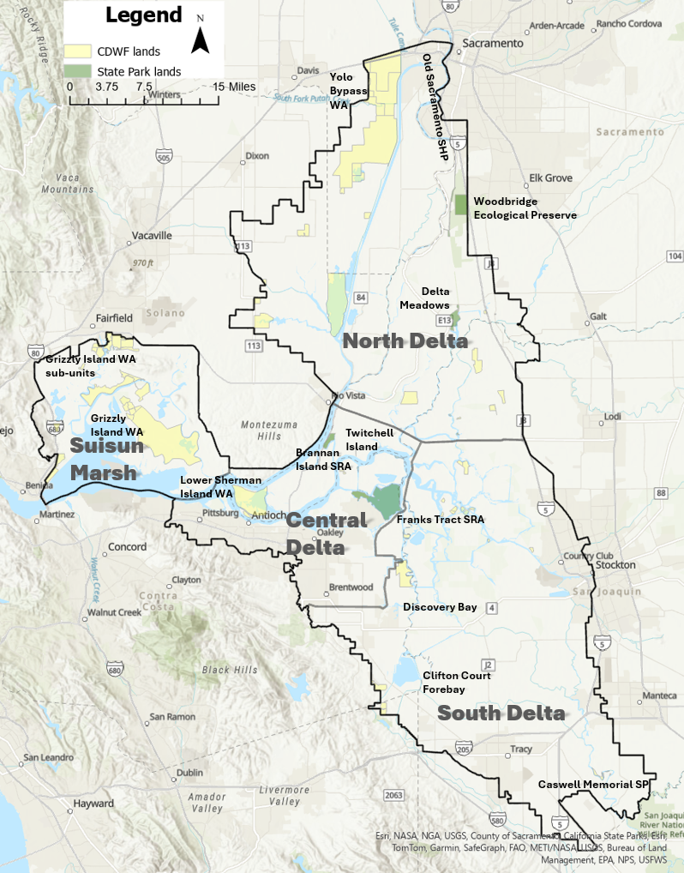
Figure 3. Four regionalized recreation zones of the Delta region for recreation analysis.

What are the Metrics?
Metric Hierarchy
- Within this framework habitat and restoration rank highest among our narratives because they are foundational to the future of the Delta, considering most islands sit between ten and thirty feet below sea level, with western Delta levees being under the most immediate dangers against inundation happening from their combined age and future sea level rise. Furthermore, while a return to historic conditions is no longer realistic, restoration that addresses beneficial scenarios and wetland expansions which support recreation may benefit economic and leisure bottom lines in the Delta region, as recreation itself is a byproduct of the leveed past, it also stands to benefit from future adaptations (Hanak, et al., 2011).

- Temperature is second. It is the single variable that shows up across nearly every activity we measure: boating, day use, bird species health risks, and harmful algal bloom expansions, all trace back to the same series of water temperature degrees, between 19°C and 23°C. Temperature drives outcomes not only from the bay, but also upstream in the system: a 2°C rise alone is projected to cut Oroville's September storage by 20 to 30% late in the summer season, regardless of changes in precipitation (Ray et al., 2020), while prior research shows recreation timing itself shifting 4.8 to 18.4 days earlier for every 2 to 3°C of warming earlier in the year (Marshall et al., 2018).

- Salinity is third. Its effects are real and foundational for recreation through the ecological species and habitats ecologic bottom lines, it is felt most directly by waterfowl and aquatic species; and in the Delta, salinity is largely a consequence of the flow and temperature conditions above it, exacerbated by urban, agricultural, and industrial users and exporters. Salinity gates in Suisun creating turbid conditions and necessitating the release of upstream cold freshwater later on during the drier summer months, create habitat conditions beneficial to endangered endemic species like the Delta Smelt (Lee, et al., 2021).

Adaptation Scenario and Tiered Outflows Metrics
We use two metrics to help measure and make sense of our narratives and activities data through: Tiered Outflows, and Adaptation Scenarios, quantitatively. Adaptation Scenarios are modelled salinity and temperature results associated with six hypothetical scenarios: Business as Usual, A Tunnel, Eco Machine, New Green Watershed, Calling on Reserves, and Bolster and Fortify as they are explained above in the criteria components section. While Tiered Outflows are also hypothetical modelled scenarios that procured a Baseline run, a +30% flows increase from baseline, and a -10% flows from the baseline.

Overall use is a metric used to define year-over-year total individual activity day thresholds that may negatively impact activities, regardless of season. Overall use helps us ascertain how many days and what months are the most affected by water-temperature and salinity under our scenarios. Seasonal use breaks down visitation for activities by the months and seasons they happen the most, or by the seasons species rely on Delta waters the most. Angling, boating, and day use peak in the summer season (April - September) when temperatures are highest and water-dependent activities are most in demand, whereas birding and waterfowl hunting at wildlife reserves peak in the winter (October - March) when migratory populations overwinter and when permits are issued for harvests. Both Overall Uses and Tiered Outflows, are measured against quantitative data from our six scenarios, which derives from once daily averages of 15-minute intervally modelled salinity and temperature data (Table 1b).

Tiered Outflows:
Daily averages from Salinity (15 minute salinity counts) | Daily averages from Temperature (15 minute temperature counts)
- Baseline  - 30% outflow increase from baseline  - 10% outflow decrease from baseline | - Baseline  - 30% outflow increase from baseline  - 10% outflow decrease from baseline

Adaptation Scenarios:
Daily averages from Salinity (15 minute salinity counts | Daily averages from Temperature (15 minute temperature counts
- Business As Usual (Baseline)  - A Tunnel  - Eco Machine  - New Green Watershed  - Calling on Reserves  - Bolster and Fortify | - Business As Usual (Baseline)  - Eco Machine  - New Green Watershed  - Calling on Reserves  - Bolster and Fortify
Table 1a and 1b. For overall use we analyzed effects on birding, waterfowl hunting, boating, angling and day use for both (a) Tiered Outflow runs (October 31st, 2020 to January 31st, 2022), and (b) Adaptation Scenario runs (October 1st, 2018 to December 1st, 2020) time-windows, while A Tunnel scenario was left out of the temperature reading for Adaptation Scenarios.

Measurement Locations
Measurement points were selected nearest to where each of our five selected water-dependent activities take place throughout the legal Delta and Suisun Marsh. Points were selected at key water corridors: near Clifton Court Forebay, the Sacramento River, the San Joaquin River, the convergence zone of the Sacramento and San Joaquin rivers, Suisun Bay, Grizzly Bay, and Honker Bay (Figure 4). We selected point counts near to already established salinity and temperature stations for Water Quality Objectives, including locations for agricultural uses, and wildlife species, then we expanded to include further upstream locations to attain best possible daily averages to inform our scenarios explained in the section above.
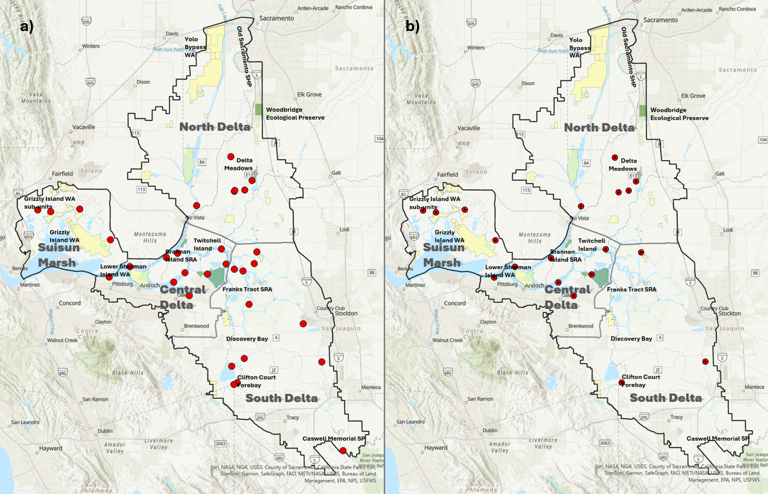
Figure 4. Delta salinity point locations chosen for a) our thirty-two Adaptation Scenario point locations, and b) our nineteen Tiered Outflow point locations.

For our quantitative analysis of both direct and indirect water-dependent recreation analysis, we used a total of 32 point locations for our Adaptation Scenarios; while 19 stations were selected for our tiered flow scenarios. This is due to the different modelling hypotheses set forth by our modelling team when creating both scenarios Tiered Outflows (-10% and +30% flows with conductivity and water temperature vs. modelled conductivity and water temperature baseline) and Adaptation Scenarios (six conductivity scenarios and five water temperature scenarios). The points we selected for recreation for either exercise were selected based on our best reasoning, and are nearest where the recreational activities we gathered data for generally take place (Table 2a lists the point locations for overall recreational uses for the Adaptation Scenarios; Table 2b lists the point locations used for the Tiered Outflow analysis).

Point Locations Used for Recreation Adaptation Scenarios
BRANNAN MARINAS AT SAN JOAQUIN RIVER | SACRAMENTO RIVER AT EMMATON
CACHE SLOUGH ABOVE RYER ISLAND FERRY | SACRAMENTO RIVER DOWNSTREAM OF ISLETON
CHADBOURNE SLOUGH AT SUNRISE DUCK CLUB | SAN ANDREAS LANDING
COURTLAND AT SACRAMENTO RIVER | SAN JOAQUIN RIVER AT BRANDT BRIDGE
DELTA CROSS CHANNEL NEAR WALNUT GROVE | SAN JOAQUIN RIVER AT JERSEY POINT
DUTCH SLOUGH BELOW JERSEY ISLAND | SAN JOAQUIN RIVER AT PRISONERS POINT
FALSE RIVER NEAR OAKLEY | SAN JOAQUIN RIVER NEAR VERNALIS
GRANT LINE CANAL NEAR CLIFTON COURT FORE | SAN JOAQUIN RIVER AT ROUGH AND READY ISLAND
GRIZZLY BAY BUOY | SUISUN BAY AT CHANNEL MARKER 5 AT COLLINSVILLE
HONKER BAY | SUISUN BAY AT VAN SICKLE ISLAND
LIBERTY CUT AT FIVE POINTS | SUISUN BAY WEST REACH
LITTLE POTATO SLOUGH AT TERMINOUS | SUISUN SLOUGH 300' SOUTH OF VOLANTI SLOUGH
MIDDLE RIVER AT MILDRED ISLAND | VICTORIA CANAL BEFORE CLIFTON COURT FORE
MONTEZUMA SLOUGH AT NATIONAL STEEL | VIERAS RESORT AT SACRAMENTO RIVER
MONTEZUMA SLOUGH NEAR BELDENS LANDING
OLD RIVER AT CLIFTON COURT
OLD RIVER AT FRANKS TRACT
PITTSBURG
Table 2a. Point locations used for analysis of adaptation scenarios.

Point Locations Used for Recreation Tiered Outflow Runs
SACRAMENTO RIVER AT EMMATON | LITTLE POTATO SLOUGH AT TERMINOUS
SAN ANDREAS LANDING | SACRAMENTO RIVER DOWNSTREAM OF ISLETON
CHADBOURNE SLOUGH AT SUNRISE DUCK CLUB | HONKER BAY
SUISUN SLOUGH 300' SOUTH OF VOLANTI SLOUGH | SUISUN BAY AT VAN SICKLE ISLAND
MONTEZUMA SLOUGH AT NATIONAL STEEL | GRIZZLY BAY BUOY
SAN JOAQUIN RIVER AT BRANDT BRIDGE | LIBERTY CUT AT FIVE POINTS
PITTSBURG | CACHE SLOUGH ABOVE RYER ISLAND FERRY
DUTCH SL BELOW JERSEY ISLAND | SUISUN BAY AT CHANNEL MARKER 5 AT COLLINSVILLE
DELTA CROSS CHANNEL NEAR WALNUT GROVE | MONTEZUMA SLOUGH NEAR BELDENS LANDING
 | GRANT LINE CANAL NEAR CLIFTON COURT FOREBAY
Table 2b. Point locations used for tiered outflow run analysis.

Metrics: Overall & Seasonal Uses
For overall recreational use we account for the frequency and intensity of each of the five selected activities at the yearly levels. While we analyze seasonal visits under our seasonal metric during their individual seasonal time windows, explained in the next metric. Our overall use metric accounts for in-season uses, shoulder season, and off-season days under a 365 day umbrella of time by creating a temperature or salinity mean for each 24 hour period from data attained every 15 minutes. Because each activity has visitor counts tallied differently, (i.e., Day, Week, month), summing each activity's total occurrences each year for the lengths of time within both our Tiered Flows, and Adaptation Scenarios by year helps normalize year-end tallies. Similarly to each activity's tallies being different, the Tiered Outflow model runs from (October 31st, 2020 to January 1st, 2022), while our Adaptation Scenario model runs from (October 1st, 2018 to December 1st, 2020).

Overall analysis considers all days of the year, beginning with the first day we have Tiered Outflows and Adaptation Scenarios data for and likewise ending on the last day we have Tiered Outflows and Adaptation Scenario data. This analysis is made to account for all instances of activities taking place within the Delta for birding, boating, day uses, fishing and waterfowl hunting, regardless of when they take place. Doing so, this analysis gives us year-over-year differences considering altogether our data spans from 2018 to 2022 (Table 3) Year breakdowns give us a scope of (2018) below normal, (2019) wet, (2020) dry, (2021) critical, (2022) critical; help inform our scenario inferences by having both wetter and drier years represented. Although year types are only referential, they complete the image of what hydrologic conditions these scenarios are being analyzed under, even if modelled, while using the real Sacramento Unimpaired (40-30-30) index to bin the results.

Units of measurement (Overall Use)
Angling  Temperature – (Pien, et al., 2024)  Salinity (sturgeon) -- (Sellheim, et al., 2022)  Salinity (bass) -- (Le Doux-Bloom, et al., 2022)  Other Delta Thresholds – (California Waterboards, 2025) | Temperature:  Chinook Salmon Adult: Average:20.6°C, Suboptimal:21°C, Tolerant:23°C-26°C  Sacramento Splittail Adult: Average:19°C, Suboptimal:24°C, Tolerant:29°C  Steelhead Adult: Average: 16.7°C, Suboptimal:20°C, Tolerant:25.5°C  Stripped bass Adult: Average: 20°C, Suboptimal:24°C, Tolerant:28°C  White Sturgeon Adult: Average: 15.8°C, Suboptimal: NA, Tolerant: NA  Temperature measurements Used (lower limit: 18.42°C; suboptimal limit 22.25°C, across species)  Salinity:  Selected for top two most recurring angled species:  White Sturgeon preferred habitation at medium salinity (2 – 10 psu) across all ages  (low band 2 PSU ~ 3.8 dS/m, or ~3,800 μS/cm), (high band 10 PSU ~17.0 dS/m, or ~17,000 μS/cm)  Adult striped bass (Age-II, III) surveyed inhabit (5.1–18.0‰ mesohaline salinity)  (low band 5.1‰ ~9.1 dS/m, or ~9,130 μS/cm). (high band 18‰ ~29.2 dS/m, or ~29,170 μS/cm)  Measurement threshold used (shared preference range) between species: ( 9,130 μS/cm lower shared habitat threshold; 17,000 μS/cm upper shared habitat threshold, and 19,000 μS/cm upper Delta & Suisun WQO thresholds for fish and wildlife beneficial uses)
Birding  (Rocke and Samuel 1999) | Temperature:  >20°Celsius water temperature increases risk of avian botulism in wetlands  Salinity:  >2.64 dS/m (2,640 μS/cm) associated with the risk of botulism increases in wetland avian species
Boating  (Lehman, et al., 2022) | Temperature:  19°Celsius water temperature eases conditions for HABs blooming after a period of ~14 continuous days over 19C threshold  Salinity:  >1.0 dS/m (1,000 μS/cm) associated with agricultural uses implied to affect landscape quality for aesthetic purposes associated with recreation
State Park Day Uses  HAB potentiality threshold – (Lehman, et al., 2022)  Salinity threshold – (California Waterboard, 2025)  Swimming thresholds – (World Aquatics, 2026) | Temperature:  <18°C Open water conditions are for swimming are too cold  - If Water residence time + >19°C over about ~14 days, then Day thresholds are crossed (same to boating) water use conditions are inadequate for Day Uses due to potential harmful blooming HABs  Salinity:  >1.0 dS/m (1,000 μS/cm) associated with agricultural uses implied to affect landscape quality for aesthetic purposes associated with recreation
Waterfowl Hunting  (Schacter, et al., 2021) | Temperature:  23°Celsius mean temperature under which the below conductivity readings happened (Suisun Marsh)  Salinity:  (3.6–10.1 μS/cm): sub-lethal effects, including reduced growth rates, reduced feather growth, and delayed molt to juvenile plumage  (10.1–14.8 μS/cm): sub-lethal effects, including severely impaired growth and lethargy  (14.8–19.2 μS/cm ): sub-lethal effects on growth and some observed mortality
Table 3. Activities and associated temperature and water salinity thresholds associated with known shifts in activity participation, and induced ecologic species changes, alongside each threshold are the citations of previous works we used to create them.

Methods (Overall Use)
Initial data cleaning steps before calculating our threshold exceedances begin with converting electrical conductivity (EC) values to $μS/cm$ (microsiemens per centimeter) from dS/m (desisiemens per meter) either at the activity threshold level or at the tiered outflows and adaptation scenarios levels. Second, we opted for a daily average of the 15-minute salinity and temperature counts from our primary data source, rather than the daily minimum or maximum readings of temperature and electroconductivity values. This is a conservative choice: a day with a brief spike above threshold but a lower daily average would not register as an excess under this method, helping us attain the best expected seasonal flows and temperature outputs. Original individual salinity and temperature thresholds for each of the five activities were attained from cited sources found in Table 3. Empirically, our Overall Use metric across five recreation activities: angling, birding, boating, day use, and waterfowl hunting is calculated by applying our exceedance formula at the overall scenario scale, meaning we measure every calendar day that exceeds activity thresholds within our study periods independently by activity and threshold, against the total number of calendar days in the study period and multiply by 100, hence attaining our threshold exceedance days.

$\% Threshold Exceed= \frac{Calendar days exceeding the thresholds (temp|salinity)}{Total number of calendar days in the study period} x 100$

The above equation is best understood when read the following way: threshold days exceeded for birding in August, are the result of a calculation where the days that cross the threshold(s) for birding (2.64 /cm or >20°C) are divided by overall days per scenario and year yielding us a percent threshold exceedance of days; which for bird importance thresholds, all 31 days in 2019 crossed the 20°C adaptation scenarios thresholds (See Table 5, for bird example, below). Which essentially means, under adaptation scenarios, in August of 2019 flow conditions in our modelled data shows all days of that month as detrimental to the health of birds, temperature-wise.

Units of measurement (Seasonal Use)
Angling  (Pien, et al., 2024) | Temperature:  Average Conditions: 18.42°C across species  Suboptimal 22.25°C across species  Tolerant Conditions: 27.13°C across species | Season:  Off-season= October to April  In-season (summer) = May-September  (Pien, et al., 2024; Jenkins, et al., 2026)
Birding  (Rocke and Samuel 1999) | Temperature:  20°Celsius water temperature increases risk of avian botulism  Salinity:  > 2.64μS/cm increases risk of botulism in wetland avian species | Season:  Fall Migration =August to October  Spring Migration = April to June  (DeLuca, et al., 2021)  Winter = October to April  (Jenkins, et al., 2026)
Boating  (Lehman, et al., 2022) | Temperature:  19°Celsius water temperature eases habitat expansion for HABs worsening water quality | Season:  Summer Season = May to September  (Jenkins, et al., 2026)
State Park Day Uses  (Lehman, et al., 2022); (California Water Boards EIR/EIS Ch. 8, 2016); (World Aquatics, 2026) | Temperature:  <18°C Open water conditions are for swimmers are too cold  >31°C Open water conditions for swimming are too warm  Algal blooms: (Narrative) swimming conditions are poor if algal blooms are present  - If Water residence time + >19°C Day thresholds are crossed (same to boating) water use conditions are inadequate for Day Uses due to implied HABs presence | Season:  Summer season = May to September  (Jenkins et al., 2026)
Waterfowl Hunting  (Schacter, et al., 2021) | Temperature:  23°Celsius mean temperature under which the below conductivity readings happened (Suisun Marsh)  Salinity:  (3.6–10.1 μS/cm): sub-lethal effects, including reduced growth rates, reduced feather growth, and delayed molt to juvenile plumage | Salinity & Temperature  Brooding Season: April to July  (only Scenarios data)  (Schacter, et al., 2021)  Hunting Season = October to February  (Scenarios + hunting takes data)  (Jenkins, et al., 2026)
Table 4. Recreational activities with associated in-season defined time periods and associated parameter setting literature.

Methods (Seasonal Use)
Similarly to our Overall Use metric we measure how indirect and direct water dependent activities interact with temperature and salinity threshold days that are crossed, both at the activity effect level and at the season days level, with a formulaic caveat we explain in the seasonal methods section below. The datasets remain the same, however in important regards, each activity and each activity's metrics are done independently of each other for both Adaptation Scenarios and Tiered Outflows. The clear new step for seasonal use which we did not use under our overall use umbrella, is the removal of non peak-season counts, accounting only for reasoned in-season use counts only. This is where this test diverts from the overall use metric. Salinity and temperature stations-wise, we kept the same stations throughout the Delta that we employed for overall use, referenced above in Tables 2a and 2b, in order to maintain cross-validity amongst overall and seasonal test results.

At the seasonal breakdown, each activity has its own seasonal calendar tied to each activity’s biological or behavioral rationale (i.e., waterfowl’s defined winter hunting season versus its fledging and brooding season early-midsummer); for all the selected five activities, we explain the seasonal rationales we measure behind each activity (Table 4). Unlike our Overall Uses, our seasonal use methodology is not controlled by continuous years; instead, we use each activity’s peak season(s) and months against thresholds to reflect how Tiered Outflows and Adaptation Scenarios reflect visitor timing and volume outcomes unique to each activity. Our a priori thinking leads us to believe that some seasonal (summer dry time of year) thresholds we use are expected to be crossed less, if at all, during winter (wet time of year). But we apply them even if they are summer thresholds being applied to a winter activity, so as to make a bespoke assessment that considers a continuous overall year window, followed by a peak use window, creating a 1-to-1 referenceable assessment with overall use breakdowns (i.e., Birding's 20°C/2.64 µS/cm thresholds are constant across winter peak use, as they are for overall assessments across all yearly seasons). For the seasonal use breakdown, exceedance was the outcome, as a percentage of each activity-specific season defined as (S) in the seasonal exceedance formula, where the number of threshold-crossing days exceeded a given (S) seasonal threshold (numerator, which is divided by the denominator, or the total number of season calendar days within that same season, then multiplied by 100).

$Threshold Exceedance= \frac{Number of in-season days where daily mean (temp|salinity)}{Total number of in-season days} x 100$

This formula was computed independently for each activity and season and repeated separately for each Adaptation Scenario and Tiered Outflows, allowing direct comparison of exceedance rates across scenarios within the same seasonal window. Days falling outside an activity's defined study season(s) were excluded from the calculation entirely or referred to as (off-season). Notably, for some activities, the initial and final season windows were shortened because the beginning or end dates of the Tiered Outflows and Adaptations scenarios did not cover those dates, as defined by our model parameters. Second, some activities do not overlap with our scenario windows or our seasonal windows; thus, we count numerator threshold days using our continuous scenario data and derive the activity threshold days from there. However, because we can indirectly ascertain the seasonal threshold days crossed by merely looking at overall results and cropping out the off-seasons (and thus rendering this step ambiguous), we actually change the formula for this assessment by changing both the numerator and denominator values to represent only real activity days when our activities happened within peak season as our numerators. This step gives us real insight into how many times an activity happens in-season and how many times the activity occurs above the ecological and temporal thresholds we use. The “real-activity threshold” results are in the recreation appendix for seasonal uses.

Adaptation Scenarios Analysis
- No water temperature data was procured for a tunnel scenario, and hence adaptation scenarios temperature analysis only includes five scenarios.

Tiered Outflows Analysis
- Tiered outflows was measured from October 2020 to January 2022, only giving us one full year window for analysis, truncating extrapolative narrative, however, with 2021 being a Critical water year, the analysis of flow during that time period is highly important for future work and worth analyzing.

Results
Overall comparative scenario summaries
The objective of this work is to understand how publicly accessible opportunities for recreation activities that depend on water resources are influenced by climate and development adaptation scenarios, which involve landscape-level and land use changes, hard infrastructure interventions, and operational decision changes. As a result, these scenarios have different associated salinity fields, water temperature ranges, and water age timelines. These recreational activities serve as proxies for human behavioral response to landscape conditions, and in recognition that activities generally occur in response to anticipated hydroclimate and resource availability conditions (Wilkins and Horne, 2024).

Business as Usual (The Norm)
Under business as usual, drought and wet years will keep shifting when, where, and how often people can access opportunities for water-dependent recreation in the Delta. Longer stretches of drought will become more common in the Delta, and will bring real ecological changes: more submerged weeds, warmer water, and invasive species spreading further east of the river convergence zone east of Antioch and into the Delta (Gross et al., 2019).

During periods of drought water-based recreation is often limited or closed at some sites for safety, especially late in the season, when reservoir releases are used to hold back saltwater intrusion under state water-rights rules (Durand et al., 2020). Winter recreation faces the opposite problem from both directions: dry summers leave less wetland and farmland habitat for waterfowl and migrating birds come fall (August to October), while wet winters can flood that same habitat and shut bird observers out (Goldstein, et al., 2024). Delta recreation, in short, rises and falls with the water year, while compounding effects of salinity intrusion alone have been attributed to the loss of roughly 10,000 general Delta-based jobs in the early 2000s (Delta Protection Commission, 2012).

Recreation will likely remain secondary to the Delta’s leading industry: agriculture, which provided 12,934 jobs in the 2000s, compared to 3,800 recreation jobs in the 2010s (Delta Protection Commission, 2012 & 2021). Furthermore, it has been noted that recent protocols recommend recreation access rather than requiring agencies to provide it (Milligan & Kraus-Polk, 2017). Investment in recreation facilities remains limited even as demand for public access grows and existing infrastructure struggles to keep up with a changing climate (Mickel et al., 2019; California Department of Boating and Waterways, 2003). Drought will also strain boat mooring capacity, and access for boaters to day use areas, which is tighter still on busy public holidays, when boaters already compete for limited space, having to also deal with water depth, especially if they own larger hull boats. Although, a recent press release by the Division of Boating and Waterways notes that there are boating infrastructure grants available for marina operators to enhance access, strengthen community ties, promote public and private partnerships, provide continuity of recreational public boating access and promote awareness (California Department of Parks and Recreation, 2026).

Eco Machine (Expanded wetlands & climate buffering)
Wetland restoration projects like Franks Tract Futures could help attenuate salinity, reduce flood risk, and keep recreation access more consistent to traffic year-round, helping support peak use seasons for both summer and winter activities. Expansively, more beaches could give boaters, swimmers, and other water users quick access to both fast-moving and deep-water zones; while providing more hunting staging areas for winter waterfowl hunting (California Department of Fish and Wildlife, 2020). Expanded wetland acreage, would not only meet core tenets of the Delta Plan (adopted in 2013 for the purpose of preserving and enhancing unique values of the Delta), extended wetland acreage, would expand state recreation areas, enhanced habitats for nature-based recreation, and further encourage recreation on public lands (Delta Stewardship Council, 2013; Ch. 5).

More wetland acreage would also help cool water at brackish convergence zones and support faster-moving water corridors, both of which tend to improve aesthetic landscape values often associated with recreation conditions. While the added murkiness that comes with moving water may affect aesthetics, this reintroduced change may actually benefit native species like Delta Smelt and Sacramento Splittail, which are adapted to turbid conditions (Hanak et al., 2011). Under hotter, drier years, expanded wetlands could hold habitat conditions in favor of native species and away from invasive ones, while also creating more habitat for resident and migratory birds. More habitat also means fewer avian botulism outbreaks, since the disease spreads fastest when habitat is scarce and conditions are dry and saline causing species to agglomerate around remaining resources (Rocke & Samuel, 1999). Overall, under this scenario, when moderate summer flows occur they would likely leave more fall habitat available for the waterfowl and birding recreationists to access (Central Valley Joint Venture, 2020; Quinn et al., 2005).

Can you add a summary sentence at the end of each scenario with your overall assumed comparative effect on recreation (benefits or impacts)?

New Green Watershed (habitat savings account)
Access to water-dependent recreation opportunities increases with moderate to substantial hydrologic runoff. Wetter runoff conditions are likely to better align with visitation numbers accounted for during above-normal to wet years, proving beneficial to both summer and winter recreation activities and shoulder seasons. Greater numbers of wetlands persisting throughout the summer benefit migrating bird and waterfowl species arriving in the fall, reducing the risk of avian disease spread by overcrowding among limited habitats (Garone, 2020). Both rewilded (incidental) and restored (proactively built) landscapes help the ecological ladder remain more stable year-over-year, helping end users like birders and waterfowl hunters (Milligan & Kraus-Polk, 2017). Directly water dependent recreation like boating and angling are likely to align with season starts, closely resembling historic expected conditions, potentially expanding recreation further into the shoulder seasons in early spring and early fall.

Results from this recreation work indicate that improved freshwater flows during wetter years maintain flows below our selected thresholds that species under our measured salinity and temperature thresholds require to steer clear from, reflecting indirectly less stress. Yearly and seasonal outputs depicting visitations happening more under real wetter conditions and less habitat stresses happening under our modelled proposed adaptation scenarios and tiered flows. Brackish water marsh sites benefit from expanded cool water flows in May and October, similarly to Eco Machine. Winter activities like birdwatching and waterfowl hunting would retain more habitat especially during drier years.

A Tunnel (loss of surface conveyance)
Under a tunnel scenario, water-based recreation would decline in certain areas as water exports and bypass flows change both year over year and seasonally, while ecologically important and recreationally important species as there would be more potential for entrainment along tunnel access points (Hanak et al., 2011). Altered timing of freshwater inflows could also mean warmer water lingering longer at shallow access points during drought, and as our models show greater salinity threshold crossing days into the wet winter season. Simply shifting the timing when people recreate, a tunnel would also shift spatially where they can.

Towns throughout the Delta strongly oppose a tunnel, fearing lost foot traffic to local businesses and a changed landscape, based on the perception that water gets routed upstream and through a tunnel instead of through the waterways themselves, with locals citing water quality changes, and construction traffic as perceived problems a tunnel would bring (Bland, 2025). Perceptions further coalesce around habitat and species health, with 2023 and 2025 Fall chinook numbers being cited as reasons for the Delta to keep more of its water to support climate affected species and the people that depend on them (Anderson, 2026).

Bolster and Fortify (Engineered Delta legacy)
Under Bolster and Fortify, recreation at year-round freshwater and storage sites would barely change in wet and above-normal years, considering the Delta already is a result of engineered solutions. Drought years are where this scenario matters as water managers would decide which sites stay open year-round, which wetlands shrink to seasonal access, and which get given up entirely to conveyance. Because infrastructure absorbs some of that seasonal water availability swing, day use near Delta storage facilities would lose visitors to upstream regions and secondary markets. As sea-level rise and land subsidence push the Delta toward relying more on fast-acting gates, barriers, and levees, recreation itself would start to run on a schedule; visitors would be arriving and leaving the water on the local infrastructure timetable rather than the seasons. This is most true in the western Delta, where seasonal access already depends on when gates and barriers open and close (Missimer et al., 2025). Some recreationists might actually turn this to their advantage, timing trips around when conveyance flows shift access in or out.

Because the Delta’s main river branches are already engineered, greenways along them would benefit from new and refurbished salinity and levee infrastructure. 150 years of engineering built for agriculture and water conveyance, already yielded scenic access as a byproduct dating back to the first state park surveys in the late 1920s which noted the natural beauty of engineered paths and levees (Milligan & Kraus-Polk, 2017; Olmsted, 1929). Using engineered structures to manage salinity and drought while moving freshwater could maintain stable recreational access, while helping support endangered species like the Delta Smelt, via salinity gates which create a low salinity, turbid zone, during operations, mimicking historical turbid fresh water flow conditions, especially around Suisun Bay and toward the end of the dry summer season (i.e., August, and September) (Lee, et al., 2021).

Calling on Reserves (Increasing stress on the Sacramento-San Joaquin Delta)
Under Calling on Reserves, recreation would decline moderately as the Delta leans harder on stored water, producing effects similar to a dry or below-normal water-year, especially later on in the summer season. Access to riverine parks would grow less predictable, especially at shallower wetlands that already struggle with HABs during drought (Lehman, et al., 2022). Recreation opportunities shrink further still, along with the broader chain of habitat on which salmonid species depend on for rearing and survival strategies. As California summers trend drier, a temperature increase of about 2° Celsius, without considering precipitation, modelled storage loss of water at Oroville would decrease by -20% to -30% for September 30th storage, but also lose -10% in spring flow (Ray et al., 2020).

Shrinking summer wetlands during brooding season would leave migrating fall species with less space; and warmer, shallower water would raise the risk of both avian botulism and harmful algal blooms (Gross et al., 2019; Donnelly et al., 2022; Schacter et al., 2021). Oddly, birding itself might look better on paper; under drier conditions birds can become easier to spot, even as the wetlands and brush they depend on erode under drought and increased foot traffic, leaving the birds themselves less resilient over time (Agulles et al., 2022). Dimensions of water use for aesthetic purposes may also become affected as Delta inflows grow more erratic in dry years, as was the case with Executive order N-7-22, which limited water uses for human and habitat health during the drought emergency in 2022.

As the causal relationship between hydroclimate changes visitation timing through the transfer of information visitors are likely to be influenced about when is best to recreate. With a 2.1° to 3.2° Celsius increase, recreation during peak summer months: June, July and August is likely to shift in linear fashion about 4.8 to 18.4 days earlier away from peak temperature days (Marshall, et al., 2018). These are trends which will inevitably affect Delta recreation as they are already having an impact in upstream recreation, with users beginning their trekking 6.8 days sooner in March, April and May when the temperature increased by 1° Celsius (Marshall et al., 2018). As storages run dry, especially during drier years, users may be forced to change the timing of their visits either to early or later season, impacting the local visitor sector.

Detailed Results

Comparative Scenarios Performance Ranking

$Score -5 to 5 =5- 10 × (\frac{days exceeding threshold}{total days in that period(month)})$

Tiered outflow analysis ranking

Adaptation scenario ranking

Implications and Discussion
Business as Usual from all of our above results reflects conditions most closely related to what conditions in the Delta reflect now, hence its namesake, rising and falling with the water year, boaters and swimmers have to deal with warm water risks every summer, while waterfowl reflect salinity thresholds similar to the 23C thresholds attained by the threshold research we used to face our own, thus affirming these conditions reflect business as usual conditions in the Delta reasonably apply a baseline scenario.

Eco Machine, built around restoring wetlands and allowing flows to reach those wetlands. Based on our results, more wetland acreage should mean fewer stressed waterfowl and bird species by nature of them having more access to land during both drier and wetter years. While recreation, important fisheries may benefit from wet years, although during drier years Eco machine flows follow wider seasonal trends.

New Green Watershed tells a similar story to Eco Machine, a wetter, more resilient Delta on paper, with real gains for birds and habitat, but gains that our threshold-day counts do not yet show clearly.
A Tunnel performed the worst of all six scenarios in what we measured, with salinity-driven botulism risk lingering into January and February when every other scenario has already cleared.

Bolster and Fortify essentially locks in current conditions through infrastructure rather than improving them. Our results back this up directly, scenario numbers track almost exactly with Business as Usual across every activity we measured. It's a scenario about stability, not improvement, however with climate temporality changing, this scenario shows that stationarity in engineered capacities, will not be able to account for loss of flows come mid-century predictions.

Calling on Reserves was the second-worst performer, right behind A Tunnel. Leaning harder on stored water in dry years extends risk for both birds and swimmers further than baseline, and it stood out in our results as the scenario most associated with unpredictable, late season arriving cold water and salinity stress lingering past when it normally clears.
For our Tiered Outflow scenarios, not having to do with changing infrastructure the clear response is: more flows help. A 30% increase in outflow cut salinity-related risk for birds and waterfowl dramatically, sometimes by 90% in a single month. Cutting flow by 10%, on the other hand, barely moved the needle from the baseline, however, marginal additions of one to two day onsets earlier in the year, particularly during drought, and at the outset, may cause a tipping point from which certain islands, species, or access points may no longer return from.

In closing, two clear stories emerge from this work. First, water management choices that lean into engineering and restrictions, for example: a tunnel, or drawing down reserves, extend salinity risk further into the calendar than doing nothing at all, while restoration-oriented choices track closer to baselines truncating salinity and temperature spikes during the summer season, at minimum, without making things measurably worse. Second, simply adding more water, even without any new infrastructure as our Tiered Outflows measure, yields greater truncating of salinity and temperature.

References
- Andrews, S. W., Gross, E. S., & Hutton, P. H. (2017). Modeling salt intrusion in the San Francisco Estuary prior to anthropogenic influence. Continental Shelf Research, 146, 58-81. 10.1016/j.csr.2017.07.010.
- Angradi, T. R., Ringold, P. L., & Hall, K. (2018). Water clarity measures as indicators of recreational benefits provided by US lakes: Swimming and aesthetics. Ecological Indicators, 93, 1005-1019.
- Al-Juaidi, A. E., & Hegazy, T. (2017). Conflict resolution for Sacramento-San-Joaquin Delta with stability and sensitivity analyses using the graph model. BJ Math Comput Sci, 20(5), 1-10.
- Anderson, T. Scott. (2026). Tribes and Allies form a Coalition Against the Delta Conveyance Project. https://www.comstocksmag.com/longreads/tribes-and-allies-form-coalition-against-delta-conveyance-project
- Bland, Alastair. (2025). ‘This will make our town uninhabitable’: The long-awaited Delta tunnel strikes fear in locals. https://calmatters.org/environment/water/2025/03/california-delta-tunnel-residents-fear/
- California Division of Boating and Waterways (2003). Sacramento-San Joaquin Delta Boating Needs Assessment: 2000-2020.
- California Department of Fish and Wildlife. (2020). Franks Tracts Futures reimagined.
- California Department of Water Resources. (2022). Delta Conveyance Project Draft EIR. Chapter 16: Recreation. https://www.deltaconveyanceproject.com/planning-processes/california-environmental-quality-act/draft-eir/draft-eir-document
- California Department of Water Resources. (2024). Hydroclimate Report: Water Year 2022. Office of the State Climatologist. https://water.ca.gov/-/media/DWR-Website/Web-Pages/Programs/Flood-Management/Flood-Data/Climate-summaries/Hydroclimate_Report_2022-ADA-Final.pdf.
- California Water Boards. (2026). HAB Reports Map. https://mywaterquality.ca.gov/habs/resources/reports-map/.
- Chang, H., & Bonnette, M. R. (2016). Climate change and water‐related ecosystem services: impacts of drought in california, usa. Ecosystem Health and Sustainability, 2(12), e01254. https://doi.org/10.1002/ehs2.1254
- Central Valley Joint Venture. (2020). 2020 Implementation Plan. Sacramento, CA: U.S. Fish and Wildlife Service. Available from: www.centralvalleyjointventure.org. https://www.centralvalleyjointventure.org/wp-content/uploads/2026/04/CVJV_2020_Implementation_Plan.pdf
- Delta Protection Commission. (2012). Economic sustainability plan for the Sacramento-San Joaquin Delta.
- Delta Protection Commission. (2015). Inventory of Recreation Facilities in the Sacramento-San Joaquin Delta. https://cawaterlibrary.net/document/inventory-of-recreation-facilities-in-the-sacramento-san-joaquin-delta-2015/.
- Delta Protection Commission. (2021). Economic sustainability plan for the Sacramento-San Joaquin Delta: Recreation and tourism chapter (2020 update).
- Delta Stewardship Council. (2013). The Delta Plan: Chapter 5 – Protect and Enhance the Unique Cultural, Recreational, Natural Resource, and Agricutltural Values of the California Delta as an Evolving Place. https://cawaterlibrary.net/document/the-delta-plan/
- DeLuca, W. V., Meehan, T., Seavy, N., Jones, A., Pitt, J., Deppe, J. L., & Wilsey, C. B. (2021). The Colorado River Delta and California’s Central Valley are critical regions for many migrating North American landbirds. The Condor, 123(1), duaa064. https://doi.org/10.1093/ornithapp/duaa064.
- Ding, Y., Hayes, M. J., & Widhalm, M. (2011). Measuring economic impacts of drought: a review and discussion. Disaster Prevention and Management: An International Journal, 20(4): 434-446.
- Donnelly, J. P., Moore, J. N., Casazza, M. L., & Coons, S. P. (2022). Functional wetland loss drives emerging risks to waterbird migration networks. Frontiers in Ecology and Evolution, 10, 844278. https://doi.org/10.3389/fevo.2022.844278.
- Durand, J. R., Bombardelli, F., Fleenor, W. E., Henneberry, Y., Herman, J., Jeffres, C., Leinfelder-Miles, M., Lund, J.R., Lusardi, R., Manfree, A.D., Medellin-Azuara, J., Milligan, B., & Moyle, P. B. (2020). Drought and the Sacramento-San Joaquin Delta, 2012–2016: environmental review and lessons. San Francisco Estuary and Watershed Science, 18(2). https://doi.org/10.15447/sfews.2020v18iss2art2
- Dybala, K. E., Sesser, K. A., Reiter, M. E., Shuford, W. D., Golet, G. H., Hickey, C., & Gardali, T. (2023). Priority Bird Conservation Areas in California’s Sacramento–San Joaquin Delta. San Francisco Estuary and Watershed Science, 21(3). https://doi.org/10.15447/sfews.2023v21iss3art4.
- Economic & Planning Systems, Inc. (2020). Franks Tract Futures Economic Assessment.
- Fink, D., Auer, T., Johnston, A., Strimas-Mackey, M., Ligocki, S., Robinson, O., Hochachka, W., Jaromczyk, L., Crowley, C., Dunham, K., Stillman, A., Davis, C., Stokowski, M., Sharma, P., Pantoja, V., Burgin, D., Crowe, P., Bell, M., Ray, S., Davies, I., Ruiz-Gutierrez, V., Wood, C., & Rodewald, A. (2024). eBird Status and Trends, Data Version: 2023; Released: 2025. Cornell Lab of Ornithology, Ithaca, New York. https://doi.org/10.2173/WZTW8903 (accessed 16 Sep 2025).
- Garone, Phillip. (2020). The Fall and Rise of the Wetlands of California’s Great Central Valley. Book. ISBN: 0520355571, 9780520355576.
- Goldman, G., McWilliams, B., Pradhan, V., & Brown, C. (1998). The Economic Impact of Recreational Boating and Fishing in the Delta. University of California Department of Agricultural and Resource Economics.
- Goldstein, B. R., Furnas, B. J., Calhoun, K. L., Larsen, A. E., Karp, D. S., & de Valpine, P. (2024). Drought influences habitat associations and abundances of birds in California's Central Valley. Diversity and Distributions, 30(5), e13827. https://doi.org/10.1111/ddi.13827.
- GreenInfo Network. (2025) California Protected Areas. https://greeninfo.org/
- Griffin, D., & Anchukaitis, K.J. (2014). ‘How unusual is the 2012–2014 California drought?’ Geophysical Research Letters, 41(24), 9017–9023. https://doi.org/10.1002/2014GL062433
- Groc, Isabelle (2015). The California Delta: Vital, Enigmatic and Ever-Changing. https://deeply.thenewhumanitarian.org/water/community/2015/09/15/the-california-delta-vital-enigmatic-and-ever-changing
- Gross, E., Andrews, S., Bergamaschi, B., Downing, B., Holleman, R., Burdick, S., & Durand, J. (2019). The Use of Stable Isotope-Based Water Age to Evaluate a Hydrodynamic Model. Water, 11(11), 2207. https://doi.org/10.3390/w11112207
- Hartman, R., Stumpner, E. B, Bosworth, D. H, Maguire, A., & Burdi, C. E. (2024). Dry Me a River: Ecological Effects of Drought in the Upper San Francisco Estuary. San Francisco Estuary and Watershed Science, 22(1). http://dx.doi.org/10.15447/sfews.2024v22iss1art5
- Hanak, Ellen, Jay Lund, Ariel Dinar, Brian Gray, Richard Howitt, Jeffrey Mount, Peter Moyle, Barton “Buzz” Thomson (2011). Managing California’s Water From Conflict to Reconciliation. https://watermanagement.ucdavis.edu/application/files/7514/5886/6517/Hanak_et_al_2011_Managing_Californias_Water_from_Conflict_to_Reconciliation.pdf
- Hochachka, W. M., Alonso, H., Gutiérrez-Expósito, C., Miller, E., & Johnston, A. (2021). Regional variation in the impacts of the COVID-19 pandemic on the quantity and quality of data collected by the project eBird. Biological Conservation, 254, 108974. https://doi.org/10.1016/j.biocon.2021.108974
- Jenkins, J. S., Abatzoglou, J. T., Wilkins, E. J., & Perry, E. E. (2023). Visitation to national parks in California shows annual and seasonal change during extreme drought and wet years. PLoS Climate, 2(8), e0000260. https://doi.org/10.1371/journal.pclm.0000260
- Lee, C. M., Hestir, E. L., Tufillaro, N., Palmieri, B., Acuña, S., Osti, A., ... & Sommer, T. (2021). Monitoring turbidity in San Francisco Estuary and Sacramento–San Joaquin delta using satellite remote sensing. JAWRA Journal of the American Water Resources Association, 57(5), 737-751. https://doi.org/10.1111/1752-1688.12917
- Lehman, P. W., Kurobe, T., & Teh, S. J. (2022). Impact of extreme wet and dry years on the persistence of Microcystis harmful algal blooms in San Francisco Estuary. Quaternary International, 621, 16-25.
- Madani, K., & Lund, J. R. (2012). California’s Sacramento–San Joaquin delta conflict: from cooperation to chicken. Journal of water resources planning and management, 138(2), 90-99. https://doi.org/10.1061/(ASCE)WR.1943-5452.0000164
- Marshall, A., Butsic, V., & Harte, J. (2018). The phenology of wilderness use: Backcountry recreation in a changing climate. Weather, Climate, and Society, 10(2), 209-223. https://doi.org/10.1175/WCAS-D-17-0087.1
- Melstrom, R. T., Nielsen, A., & Reeling, C. (2024). The recreational value of birding and crane abundance. Agricultural and Resource Economics Review, 53(3), 534-557. https://doi.org/10.1017/age.2024.10.
- Missimer, T. M., & Maliva, R. G. (2025). Salinity barriers to manage saltwater intrusion in coastal zone aquifers during global climate change: a review and new perspective. Water, 17(11), 1651. https://doi.org/10.3390/w17111651.
- Mickel, A., Taylor, S., Rollof, D., & Gregory, S. (2019). Recreation and tourism in the Delta: a study of preferences for activities and facilities, information sources, and economic contributions of Delta events. Sacramento (CA): Delta Protection Commission. https://delta.ca.gov/wp-content/uploads/2020/09/Delta-Recreation-Report-508.pdf.
- Milligan, B., Kraus-Polk, A., & Huang, Y. (2020). Park, fish, salt and marshes: Participatory mapping and design in a watery uncommons. Land, 9(11), 454. https://doi.org/10.3390/land9110454
- Mosley, L. M. (2015). Drought impacts on the water quality of freshwater systems; review and integration. Earth-Science Reviews, 140, 203-214. https://doi.org/10.1016/j.earscirev.2014.11.010
- NASA. (2023). January 5, 2023 – Flooding in California. https://modis.gsfc.nasa.gov/gallery/individual.php?db_date=2023-01-05
- Olmsted, F. L. (1929). Report of state park survey of California (Vol. 5). California state printing office.
- Palmer, T. A., & Montagna, P. A. (2015). Impacts of droughts and low flows on estuarine water quality and benthic fauna. Hydrobiologia, 753(1), 111-129. https://doi.org/10.1007/s10750-015-2200-x.
- Pien, C., Hartman, R., Bush, E., Lehman, P., & Davis, B. (2024). Thermal Stress and Suitability for Aquatic Species in the San Francisco Estuary. doi: 10.20944/preprints202409.1890.v1.
- Quinn, N., Hanlon, J., Burns, J., Stromayer, K., Jordan, B., Ennis, M., & Woolington, D. (2005). Real-Time Water Quality Monitoring and Habitat Assessment in the San Luis National Wildlife Refuge. Lawrence Berkeley National Laboratory. Retrieved from https://escholarship.org/uc/item/63v6587n
- Ray, P., Wi, S., Schwarz, A., Correa, M., He, M., & Brown, C. (2020). Vulnerability and risk: Climate change and water supply from California’s Central Valley water system. Climatic Change, 161(1), 177-199. https://doi.org/10.1007/s10584-020-02655-z
- Rocke, T. E., & Samuel, M. D. (1999). Water and Sediment Characteristics Associated with Avian Botulism Outbreaks in Wetlands. The Journal of Wildlife Management, 63(4), 1249–1260. https://doi.org/10.2307/3802842
- Rudnick, J., Heikkila, T., Koebele, E., Morrison, T., & Batavia, C. (2025). Assessing the State and Efficacy of Climate Governance Research and Practice in the Sacramento–San Joaquin Delta. San Francisco Estuary and Watershed Science, 23(1). https://doi.org/10.15447/sfews.2025v23iss1art2.
- State Water Resources Control Board. (2022). https://www.waterboards.ca.gov/press_room/press_releases/2022/pr05242022-conservation-emergency-regulations.html
- State Water Resources Control Board. (2025). Water Quality Control Plan for the San Francisco Bay/Sacramento-San Joaquin Delta Watershed. December 2025 Draft. https://www.waterboards.ca.gov/waterrights/water_issues/programs/bay_delta/docs/2025/h/dec2025-rev-draft-sacdelta-bdplan.pdf
- Smits, A. P., Durand, J. R., Williamshen, B. O., Luke, K., & O’Rear, T. (2025). Drought and Aquatic Vegetation Alter Water Clarity and Fish Assemblages in Freshwater Tidal Ecosystems of the Sacramento-San Joaquin River Delta. Estuaries and Coasts, 48(5), 120. https://doi.org/10.1007/s12237-025-01556-7
- Schacter, C. R., Peterson, S. H., Herzog, M. P., Hartman, C. A., Casazza, M. L., & Ackerman, J. T. (2021). Wetland availability and salinity concentrations for breeding waterfowl in Suisun Marsh, California. San Francisco Estuary and Watershed Science, 19(3). https://doi.org/10.15447/sfews.2021v19iss3art5.
- Shahi, M. B. (2022). Estimating Willingness to Pay for Recreational Services of Public Parks. Zenodo (CERN European Organization for Nuclear Research).
- Schwoerer, T., & Dawson, N. G. (2022). Small sight—Big might: Economic impact of bird tourism shows opportunities for rural communities and biodiversity conservation. PloS one, 17(7), e0268594. https://doi.org/10.1371/journal.pone.0268594.
- StreetLight Data, Inc. (2026). Destination Volume for select California Delta boat launch ramps: 2018 to 2022. Retrieved [August, 2025], from streetlightdata.com.
- Visit the California Delta. (n.d.). Bird Watching Spots in the Delta. https://visitcadelta.com/what-to-do/bird-watching/
- Williams, A. P., Cook, E. R., Smerdon, J. E., Cook, B. I., Abatzoglou, J. T., Bolles, K., Baek, S. H., Badger, A. M., & Livneh, B. (2020). Large contribution from anthropogenic warming to an emerging North American megadrought. Science 368(6488), 314-318. https://www.science.org/doi/10.1126/science.aaz9600
- Williams, A. P., Cook, B. I. & Smerdon, J. E. (2022). Rapid intensification of the emerging southwestern North American megadrought in 2020–2021. Nature Climate Change, 12, 232–234. https://doi.org/10.1038/s41558-022-01290-z
- Wilkins E. J., & Horne, L. (2024). Effects and perceptions of weather, climate, and climate change on outdoor recreation and nature-based tourism in the United States: A systematic review. PLOS Climate, 3(4), e0000266. https://doi.org/10.1371/journal.pclm.0000266
- World Aquatics. (2026). Competition Regulations. https://resources.fina.org/fina/document/2026/02/18/e6815ecc-06d9-4f0b-98e9-4c441cf5e6a3/2026-02-18_World-Aquatics_CR-Final.pdf.
- Wlostowski, A. N., Jennings, K. S., Bash, R. E., Burkhardt, J., Wobus, C. W., & Aggett, G. (2022). Dry landscapes and parched economies: A review of how drought impacts nonagricultural socioeconomic sectors in the US Intermountain West. Wiley Interdisciplinary Reviews: Water, 9(1). https://doi.org/10.1002/wat2.1571

